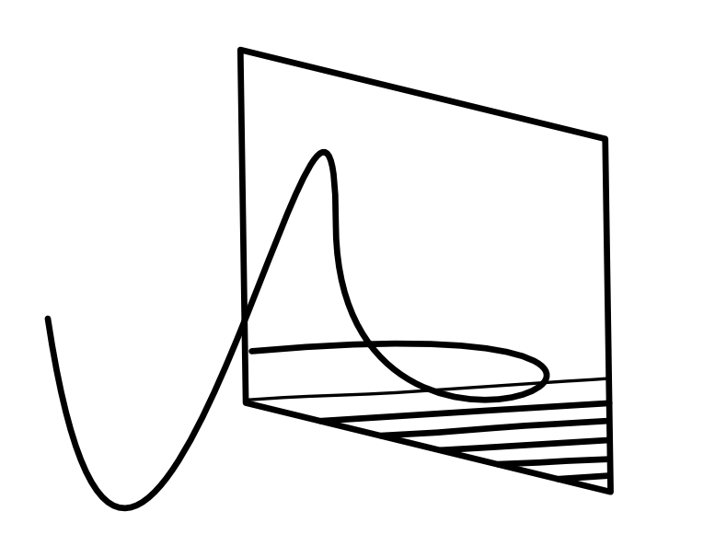

Artispace

Artispace: Detailed Application Description

1. The Executive Summary
Artispace is the next-generation digital home for professional artists. It solves the critical compromise between a static portfolio website and a distracting social media feed. Artispace is a high-fidelity, interactive platform where artists gain complete creative control over their presentation while leveraging a powerful social discovery engine to build their audience and secure commissions.
Our core value lies in treating digital art display with the same reverence as a physical gallery, supported by modern, performant technology.

2. Core User Experience: The Blend

A. For the Artist (The Portfolio)
Artispace gives artists the professional tools they need, moving beyond the simple "photo dump" of other platforms:
- Exhibition-Style Curation: Artists can group their work into flexible collections (e.g., "Monochrome Series," "2025 Retrospective," "Works-in-Progress") or post pieces as Standalones.
- Custom Presentation Engine: Each collection or profile section can be assigned a unique visual layout (e.g., a tight Masonry Grid, a focused Slideshow, or a traditional Full Gallery view) using customizable themes, ensuring the presentation style matches the artwork's intent.
- High-Fidelity Media: The platform supports and displays original, high-resolution files without aggressive compression, guaranteeing that the detail, colour, and texture of the art are accurately preserved and delivered globally at high speed via our CDN.
- Professional Protection: Original art files are protected via Pre-Signed URLs and a robust security model to prevent mass scraping and unauthorized downloading.

B. For the Viewer (The Network)
Artispace provides a focused, high-quality viewing experience driven by engaging social mechanics:
- The Personalized Feed: Viewers receive a dynamic stream of content from followed artists, prioritized by a proprietary Affinity-based Algorithm. This ensures users see the most relevant, recent work first, cutting through the noise of purely popularity-driven feeds.
- Focused Interaction: Core social features like Following, Liking, and Commenting encourage organic community building without the pressure of ephemeral content or distracting ads.
- Intelligent Discovery: The "Explore" page uses Graph Theory to recommend new, relevant artists based on the user's existing network and the stylistic tags of their saved art, fostering meaningful connections within the art community.
- Industry Vetting: The platform is designed to facilitate professional networking by potentially tagging and verifying Industry Professionals (Gallerists, Art Directors) whose engagement signals quality and opportunity for the artists.

3. Key Technical Differentiators
Artispace relies on a modern, scalable computer science architecture:
- Asynchronous Processing: Uploads are handled instantly, with heavy tasks (image resizing, thumbnail generation, feed fanout) managed in the background by Message Queues, guaranteeing a fast, responsive user experience.
- Scalable Data Model: Uses a Many-to-Many relationship structure to support flexible categorization and a Graph Data Structure for efficient social networking queries.
- Security First: Implements JWT authentication and Role-Based Access Control (RBAC) to secure every piece of data and functionality on the platform.
Artispace is not just another platform; it's the professional, interactive, and beautifully controlled home the modern artist deserves.

Artispace: Comprehensive Technical & Product Documentation

I. Vision, Problem Solved, & Differentiation
Section | Detail
Core Goal | To be the premier interactive portfolio platform that combines professional presentation quality with the organic discovery and engagement of social networking.
Unique Selling Point (USP) | Customizable, exhibition-style categorization of work with high-fidelity media delivery, eliminating the compromise between static professional sites and distracting social feeds.
Problem Solved | 1. Lack of Discovery on traditional portfolio sites. 2. Compromised Quality & Control on mass social media platforms (algorithmic control, image compression). 3. Missing Professional Context for artist-client networking.

II. Core Functional Requirements (Features)
Feature Category | Description | Back-End/CS Feature Needed
User Portfolio | Secure profile creation, management, and settings (privacy, notifications). | User Authentication (JWT), RBAC
Content Upload | Upload high-resolution images/videos. | Asynchronous Image Processing, Cloud Object Storage
Flexible Curation | Artists can define work as a Standalone Post or part of a multi-piece Exhibition/Collection. | Many-to-Many Database Modeling
Custom Presentation | Artists can choose different visual layouts (grid, gallery, masonry) and styles (colors, fonts) for their profile sections. | JSON Configuration in DB, Dynamic Front-End Rendering
Social Connections | Ability to Follow/Unfollow other artists. | Graph Data Structure (Adjacency List)
Interactive Feed | A single stream of posts from followed users, sorted by relevance. | Personalized Ranking Algorithm (EdgeRank Model)
Engagement | Likes and comments on individual pieces of art. | Indexed Database Tables, Atomic Counters
Media Quality | Art is displayed quickly and in high resolution. | Content Delivery Network (CDN), Pre-Signed URLs

III. Computer Science Architecture & Data Modeling

A. Key Data Structures
Element | Data Structure | Purpose
Social Connections | Adjacency List (Graph) | Stores who follows whom for lightning-fast feed generation.
Live Feed Ranking | Min-Heap / Max-Heap | Used by the ranking algorithm to prioritize and retrieve the most relevant posts instantly.
High-Volume Lookups | Hash Maps/Cached Counters | Stores data like follower counts and total likes for $O(1)$ lookup time, preventing database overload.
Flexible Curation | Bridge Table (Post_Category_Map) | Enables a single post to belong to multiple artist-defined "Exhibitions."

B. The Feed Ranking Algorithm (Post Score)
Formula Component | Purpose | Data Source
Affinity | Measures how interested the viewer is in the poster. | Past interactions (likes, comments, profile views) between the two users.
Weight | Measures the inherent quality/popularity of the post. | Initial velocity of engagement (likes/comments within the first hour).
Decay | Ensures new art is prioritized over old, regardless of initial popularity. | A time-based function applied to the post's Timestamp.


C. Database Schema (Conceptual)
Table/Model | Key Fields (Minimum) | Relationship Focus
Users | user_id, username, password_hash, email, role, profile_config (JSON) | Authentication & Authorization
Posts | post_id, artist_id (FK), title, media_path, timestamp, score (cached) | Content & Retrieval
Follows | follower_id (FK), following_id (FK) | Graph/Social Network Edge
Categories | category_id, artist_id (FK), category_name, display_config (JSON) | Custom Portfolio Structure
Post_Category_Map | post_id (FK), category_id (FK) | Many-to-Many Bridge (Standalone or Collection)

IV. Security & Defense Strategy
Security Requirement | CS Implementation | Defense Against
User Identity | Bcrypt/Argon2 Hashing with Salt for passwords. | Database breaches (prevents password recovery).
Secure Sessions | JSON Web Tokens (JWT) sent via HTTP-Only Cookies. | XSS (Cross-Site Scripting) attacks.
Resource Control | Role-Based Access Control (RBAC) + Ownership Check on all API calls. | Unauthorized data modification/deletion.
Art Protection | Pre-Signed URLs for high-res downloads; direct links are blocked. | Content Scraping and mass downloading.
Input Safety | Server-Side Input Validation on all form data. | SQL Injection and XSS attacks.

V. Future Roadmap & Implementation Plan

A. Short-Term Implementation (MVP Phase)
The first milestone focuses on delivering a functional, secure, and visually consistent platform prototype suitable for early artist onboarding and user testing.
Goal | Description | Implementation Focus
1. Core Platform Setup | Develop secure authentication and user profile management. | Implement JWT Auth, RBAC, and user CRUD APIs using Node.js or Django REST.
2. Media Handling Pipeline | Enable reliable upload, processing, and CDN distribution of high-resolution images. | Integrate AWS S3 + Lambda (or Cloudinary) for async media processing.
3. Exhibition Module (Portfolio Builder) | Artists can create exhibitions and upload artworks with metadata. | Implement Post–Category schema, bridge tables, and JSON-based layout configs.
4. Interactive Feed (Viewer Experience) | Display a dynamic feed of posts from followed artists. | Build Affinity–Weight–Decay ranking prototype with mock dataset.
5. Front-End UI/UX | Create a high-fidelity, responsive portfolio display interface. | Use React + Tailwind or Next.js with JSON-rendered layouts.
Deliverable: MVP Launch (v0.1) — core back-end + front-end integration, demo-ready for user trials and feedback.

B. Mid-Term Development (v1.0 Launch)
The second phase strengthens the social network and discovery components to make Artispace a professional ecosystem.
Goal | Description | Technical Focus
1. Discovery Engine | Build a graph-based artist recommendation system. | Implement Graph Traversal Queries (e.g., Neo4j, NetworkX).
2. Advanced Analytics | Enable artists to view engagement data and insights. | Introduce dashboard module with cached counters and visual reports.
3. Enhanced Security Layer | Expand protection for artwork and personal data. | Add rate limiting, 2FA, and audit logs.
4. Community Tools | Integrate verified gallerist and curator profiles. | Implement a role tagging system and trust indicators.
Deliverable: Public Beta Release (v1.0) — complete portfolio–network hybrid with production-grade scalability.

C. Long-Term Vision (v2.0 and Beyond)
Artispace aims to become the definitive digital art infrastructure for contemporary creators — integrating AI, immersive technology, and professional monetization.
Vision Pillar | Expansion Direction | Potential Technologies
AI-Driven Curation | Personalized exhibition design and caption generation. | Generative AI + embeddings-based style matching.
AR/VR Integration | Artists can host immersive 3D exhibitions. | WebXR, Three.js, Unity WebGL.
Blockchain Provenance | Optional on-chain ownership certificates for digital art. | Ethereum L2 or Polygon NFT metadata (non-speculative).
Collaborative Studio Mode | Shared creative spaces for teams and collectives. | Real-time synchronization using WebSockets or CRDTs.
API Ecosystem | External integration with galleries, curators, and art educators. | REST + GraphQL APIs with OAuth2.
Deliverable: Artispace Ecosystem (v2.0) — an intelligent, secure, and artist-empowering digital platform blending exhibition, connection, and technology.

D. Evaluation & Sustainability
Area | Evaluation Metric | Method
User Experience | Retention, engagement time, and feedback scores | Beta surveys and heatmap analytics
Performance | API response time, CDN latency | Load testing with JMeter
Security | Vulnerability reports, intrusion detection logs | Quarterly audits
Scalability | Uptime under simulated load | Auto-scaling tests on the cloud provider
Community Impact | Artist reach, verified partnerships | Social graph growth and qualitative interviews

STACK - Production-leaning / what this could grow into
Frontend
- Next.js (App Router), Tailwind, shadcn/ui
- Image component to optimize delivery
- Maybe a separate “public gallery” domain later
Backend (services)
- NestJS (TypeScript) for structured modules: auth, users, posts, collections, feed, and admin.
- GraphQL or REST — REST is simpler at first.
- RBAC middleware in NestJS.
Data
- PostgreSQL for core entities.
- Redis for:
  - feed fanout caches,
  - follower counts,
  - rate limiting.
- Optional: Neo4j or a graph service if you really want to experiment with graph-based discovery later — but don’t start here.
Queues / async
- RabbitMQ or Redis Queue (BullMQ) for:
  - image processing,
  - feed fanout,
  - notification delivery.
Storage/CDN
- S3 → CloudFront (or Supabase storage + CDN if you want easier dev).
Infra
- Dockerize services
- Deploy to Render / Railway / Vercel (frontend) + Fly.io/Render (backend)

